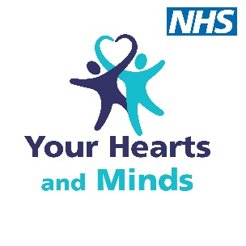
Your Hearts and Minds application for community grant funding

Name of applicant: ……………………………………………………………………………….
Charity or voluntary sector organisation: …………………………………………………….
In conjunction with:
RDaSH staff member Name: …………………………………………………………………….
RDaSH service: ……………………………………………………………………………………
Date submitted: ………………………………………………………………………………

Bid application title: ……………………………………………………………………………..

Fundraising priority (please select):
- a good start
- our best self
- a good death
- research
- promoting education and learning

Community partner’s details
Name of local charity or voluntary sector body partner:
…………………………………………………………………………………….

Address: ………………………………………………………………………..
……………………………………………………………………………………..
……………………………………………………………………………………..

Contact name: ………………………………………………………………….

Registered charity number (if applicable): …………………………………………
Outline the scheme or project stating the type of activity, estimated cost and who will benefit.
Please ensure your application answers the following:
- What is the scheme or project aiming to achieve? No more than 250 words.

- What will be the specific benefit to the patients, carers, staff or the community? No more than 250 words.

- How much are you applying for (between £1000 and £3000) and what will the money be spent on? No more than 250 words.

- What impact will this project/scheme have? No more than 250 words.

